

**GCP – HOL -Session 17**

This page shows you how to monitor a Compute Engine virtual machine (VM) instance with Stackdriver. If you want to monitor an Amazon EC2 VM instance, see [Quickstart for Amazon EC2](https://cloud.google.com/monitoring/quickstart-aws).

In this quickstart, you do the following:

1. Create a Compute Engine VM instance.
2. Install Apache HTTP Server.
3. Install the Stackdriver Monitoring and Logging agents.
4. Create an uptime check with an alerting policy.
5. Create a custom dashboard and chart.
6. View your logs.
7. Clean up.

## Before you begin

To use Stackdriver Monitoring, you need to create a GCP project, enable billing for your project, and associate your project with a Workspace.

### **Create a project**

To create a project:

1. In the GCP Console, go to **New Project**.

[CREATE A NEW PROJECT](https://console.cloud.google.com/projectcreate)

1. In the **Project Name** field, enter Quickstart.
2. Click **Create**.

To enable billing for your project:

1. In the GCP Console, go to **Billing**.

[GO TO BILLING](https://console.cloud.google.com/billing)

1. Select your Quickstart project if it isn't already selected at the top of the page.
2. You are prompted to choose an existing payments profile or to create a new one.

### **Create a Workspace**

To create a Workspace for an existing GCP project, do the following:

1. Go to the GCP Console:

[GO TO GCP CONSOLE](https://console.cloud.google.com/)

1. In the menu bar, click the drop-down list next to the **Google Cloud Platform** and select your GCP project.
2. Click **Monitoring**.
3. If the **Add your project to a Workspace** dialog is displayed, create a new Workspace by selecting your GCP project under **New Workspace** and then clicking **Add**. In the following image, the GCP project name is Quickstart:

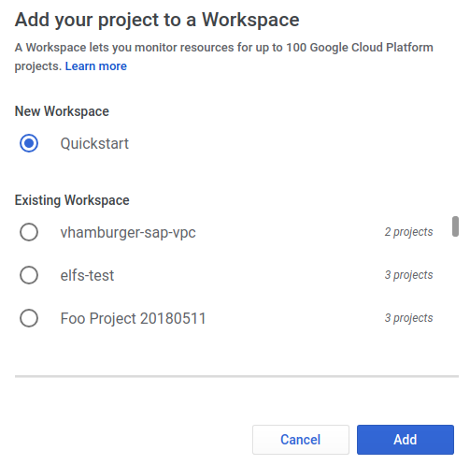

The **Add your project to a Workspace** dialog is displayed only when you have at least one existing Workspace available to you. The Workspaces listed under **Existing Workspace** are Workspaces you've created or Workspaces for GCP projects where you have editorial permission. Using this dialog, you can choose between creating a new Workspace and adding your project to an existing Workspace.

Next, Monitoring creates a new Workspace and adds your GCP project to the Workspace. During Workspace creation, Monitoring proceeds through the following phases:

1. Building your Workspace
2. Enabling Stackdriver APIs
3. We're still collecting data for your new Workspace

These phases might take several minutes to complete. When this process is complete, the Stackdriver Monitoring console displays the **Monitoring Overview** pane and a welcome message:

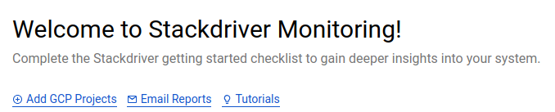

## Create a Compute Engine instance

1. In the GCP Console, go to **Compute** > **Compute Engine**.

[GO TO COMPUTE ENGINE](https://console.cloud.google.com/compute)

1. To create a VM instance, click **Create**.
2. Fill in the fields for your instance as follows:
   * In the **Name** field, enter lamp-1-vm.
   * In the **Machine type** field, select **Small**.
   * In the **Firewall** field, select both **Allow HTTP traffic** and **Allow HTTPS traffic**.

Leave the rest of the fields at their default values.

1. Click **Create**. Wait a couple of minutes for your instance to launch on the VM Instances page.
2. To open a terminal to your instance, in the **Connect** column, click **SSH**.
3. Update the package lists on your instance.

sudo apt-get update

1. Set up the Apache2 HTTP Server.

sudo apt-get install apache2 php7.0

**Note:** If the above command fails, use **sudo apt-get install apache2 php**. If asked to continue the installation, enter **Y**.

1. Open your browser and connect to your Apache2 HTTP server by using the URL http://[External IP]. Replace [External IP] with the external IP address of your Compute Engine instance. You see the Apache2 default page:

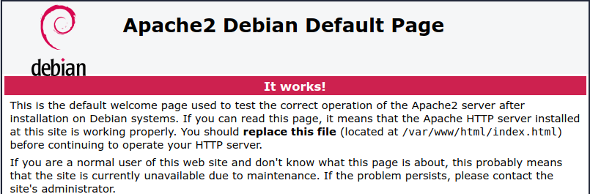

## Install the Stackdriver agents

The Stackdriver Monitoring and Logging agents pass logs and metrics from your VM instance to Monitoring and Logging:

1. Switch to the terminal connected to your VM instance or create a new one.
2. Install the Stackdriver Monitoring agent.

curl -sSO https://dl.google.com/cloudagents/install-monitoring-agent.sh  
sudo bash install-monitoring-agent.sh

1. Install the Stackdriver Logging agent.

curl -sSO https://dl.google.com/cloudagents/install-logging-agent.sh  
sudo bash install-logging-agent.sh --structured

The --structured flag lets the Logging agent send structured data to Stackdriver Logging. For more information, see [Structured logging operations](https://cloud.google.com/logging/docs/structured-logging).

## Create an uptime check

Uptime checks verify that your web server is accessible from locations around the world. The alerting policy controls who is notified if the uptime checks should fail.

To create an alerting policy using that check:

1. Go back to the Stackdriver Monitoring console.

[GO TO MONITORING](https://app.google.stackdriver.com/)

1. If you see the invitation **Create an Uptime Check** on the dashboard, then click it. Otherwise, go to **Uptime Checks** > **Uptime Checks Overview** and then click **Add Uptime Check** or **Create an Uptime Check**.
2. Fill in the following fields for the new uptime check:
   * In the **Title** field, enter My Uptime Check.
   * In the **Resource Type** drop-down list, select **Instance**.
   * In the **Applies To** field, enter Single, lamp-1-vm.
   * Leave the other fields with their default values.

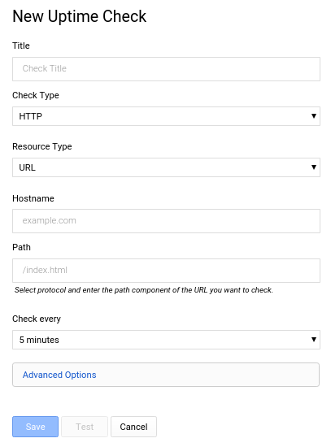

1. To verify that your uptime check is working, click **Test**. If you see a "Connection error - refused" message, you might have not installed the [Apache HTTP Server](https://cloud.google.com/monitoring/quickstart-lamp#install-apache) or you might have specified the **HTTPS** check type rather than **HTTP**. For other errors, see [Verify your uptime check](https://cloud.google.com/monitoring/alerts/uptime-checks/#verify-check).
2. When you click **Save**, the following dialog displays:

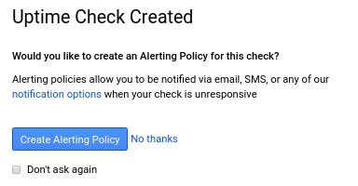

## Create an alerting policy

1. In the **Uptime Check Created** pane, click **Create Alerting Policy**.
2. In the **Untitled Condition** field, enter a title for the alert policy condition. All other fields are in the conditions pane are automatically populated from the uptime check you created.

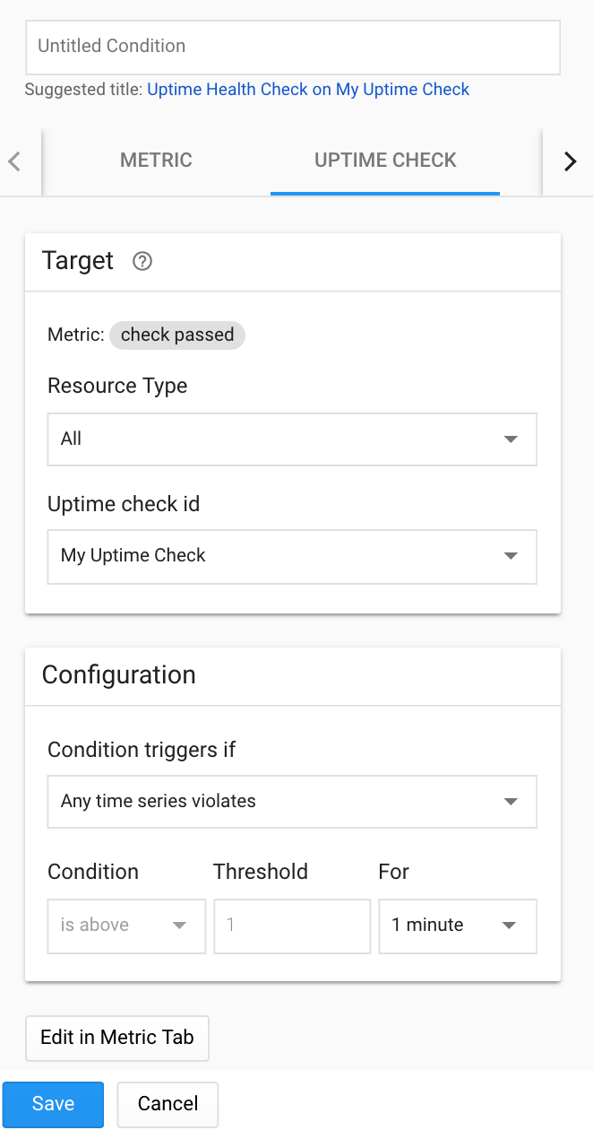

1. Click **Save**.
2. In the **Notification Channel Type** drop-down list, select **Email**.

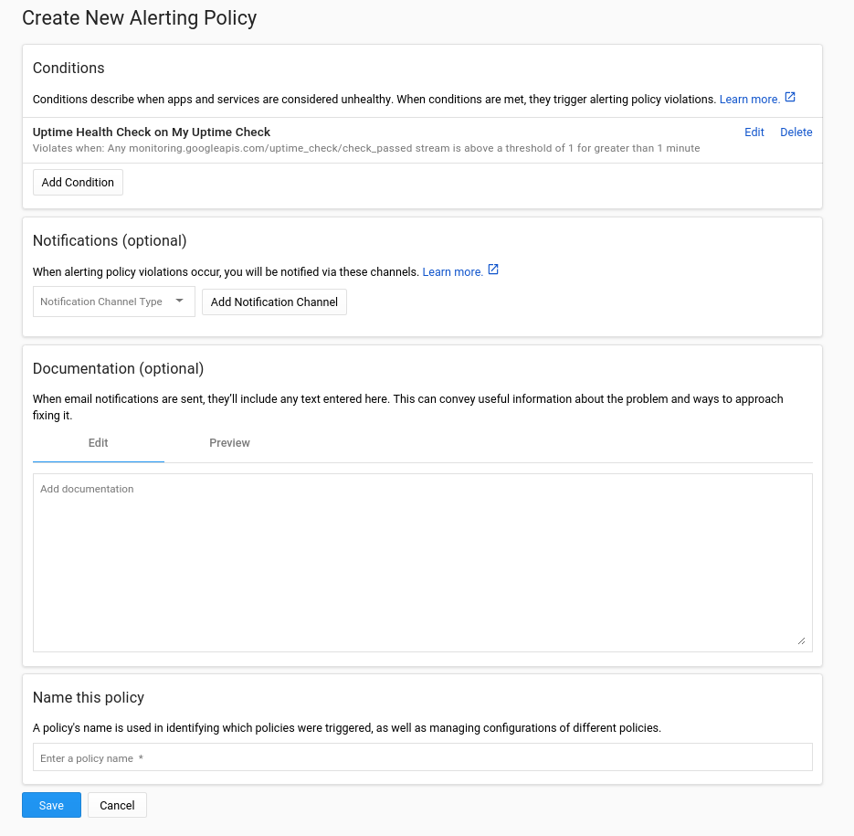

1. Enter your email address and then click **Add Notification Channel**.
2. In the **Name this policy** pane, enter My Uptime Check Policy.
3. Click **Save**. You see a summary of the policy.

## Create a dashboard and chart

Display the metrics collected by Monitoring in your own charts and dashboards.

1. In the Stackdriver Monitoring console, go to **Dashboards** > **Create dashboard**.

[GO TO THE CREATE DASHBOARD PAGE](https://app.google.stackdriver.com/monitoring/new)

1. In the upper-right hand corner, click **Add Chart**.
2. In the **Add Chart** window, click the **Metric** tab.

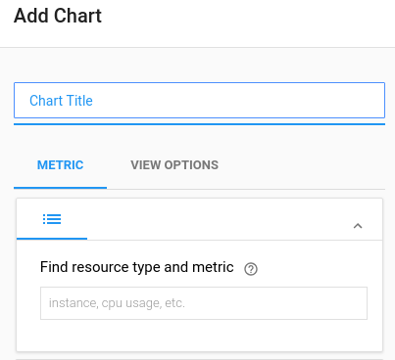

1. Under **Find resource type and metric** heading, in the **instance, cpu, usage, etc.** field, enter **CPU**, and then select**CPU load(1m)** from the drop-down list. Leave the other fields with their default values.
2. When a new chart appears in the **Preview** section of the panel, click **Save**.

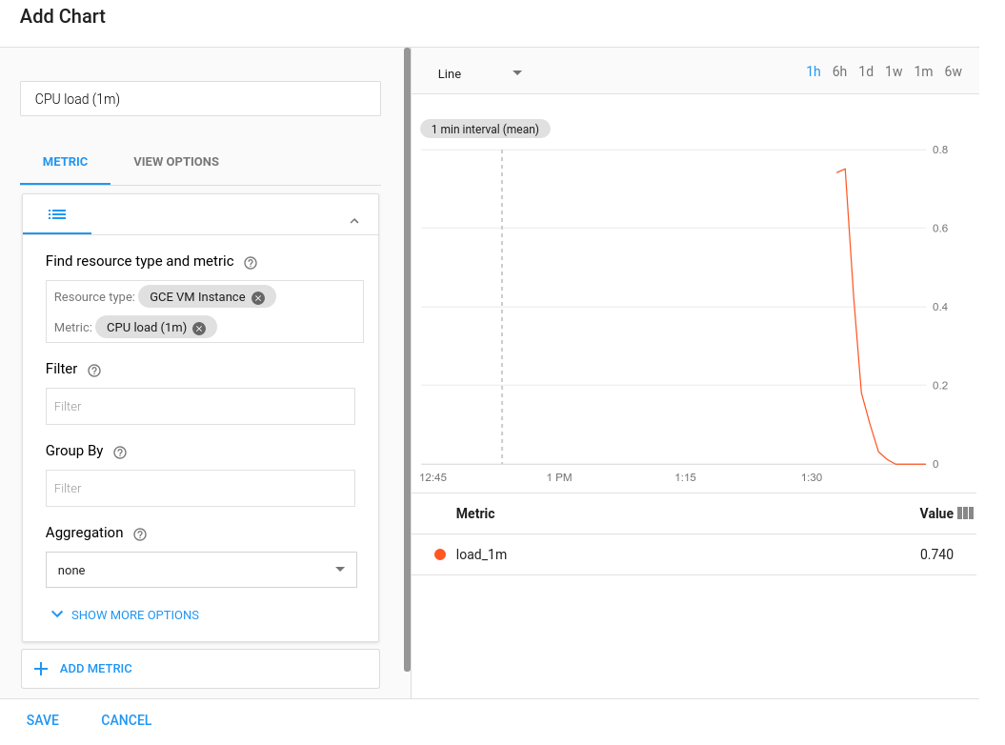

1. To create a second chart, click **Add Chart**.
2. Click the **Metric** tab.
3. In the **Find resource type and metric** drop-down list, select **Received bytes**. Leave the other fields with their default values.
4. When a new chart appears in the **Preview** section, click **Save**.
5. In the new dashboard, change **Untitled Dashboard** to Stackdriver quickstart dashboard.

## Test the check and alert

This procedure can take up to 40 minutes. A sample timeline is included for your reference. In the timeline, the current time is 12:00.

**12:00 Wait**

Return to the [Stackdriver Monitoring console](https://app.google.stackdriver.com/). Wait until the icon next to the **My Uptime Check** changes from a gray circle with an exclamation mark to a green circle with a check mark. The maximum wait time for this stage is 5 minutes:

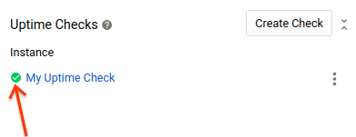

**12:15 The My Uptime Check icon is green. Test the check and alert.**

Go to the [VM Instances](https://console.cloud.google.com/compute/instances) page, select your instance, and click **Stop**.

**12:25 Alert notification received.**

Correct the "problem" by restarting the VM. Return to the [VM Instances](https://console.cloud.google.com/compute/instances) page, select your instance, and click **Start**.

**12:40 Incident Resolved**

Received second alert notification.

## View your logs

Monitoring and Logging are closely integrated. To view your logs:

1. In the [Stackdriver Monitoring console](https://app.google.stackdriver.com/), click **Logging**:

[GO TO STACKDRIVER LOGGING](https://console.cloud.google.com/logs/viewer)

1. Change the **Logs Viewer** settings to see the logs you want:
   * In the first drop-down list, select **G​C​E VM Instance, lamp-1-vm**.
   * In the second drop-down list, select **syslog**, and click **OK**.
   * Leave the other fields with their default values. The logs from your VM instance display.

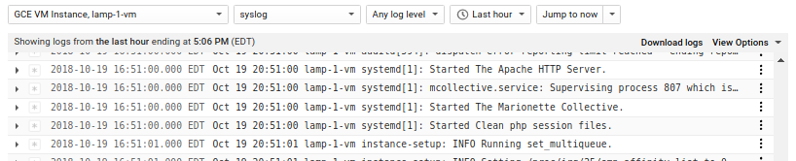

1. Return to the [Stackdriver Monitoring console](https://app.google.stackdriver.com/). To view your logs, in one of your charts, click the **menu** icon, and then click **View logs**.

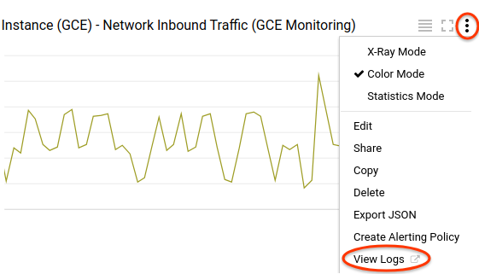

## Clean up

To avoid incurring charges to your GCP account for the resources used in this quickstart:

### **Clean up Stackdriver**

Remove your Stackdriver alerting policies, uptime checks, and chart so that you won't get errors when you shut down your VM instance.

To delete your alerting policy:

1. In the [Stackdriver Monitoring console](https://app.google.stackdriver.com/), go to **Alerting** > **Policies Overview**.
2. Click **Delete** next to the policy that you wish to remove.

To delete your uptime check:

1. In the [Stackdriver Monitoring console](https://app.google.stackdriver.com/), go to **Uptime Checks** > **My Uptime Check**.
2. Click **Delete uptime check**.

To delete your charts:

1. In the [Stackdriver Monitoring console](https://app.google.stackdriver.com/), go to **Dashboards** > **Stackdriver quickstart dashboard**.
2. For each chart, click **Delete**.
3. When the dashboard is empty, click the **menu** icon, and then click **Delete**.
4. In the "Confirm Chart Deletion" panel, click **Delete**.